**

**Softech** **Solutions Inc.**

[www.softechsolutionsgroup.com](http://www.softechsolutionsgroup.com)

[saney.alam@softechsolutionsgroup.com](mailto:saney.alam@softechsolutionsgroup.com%20)

# A Complete Guide for Beginners

Selenium – Environment Setup

***Lecture Notes***

Selenium – Environment Setup

|  |  |
| --- | --- |
| ***Table of Contents Page*** | |
| ***Download Selenium WebDriver Java Client*** | ***02*** |
| ***Configure Eclipse with Selenium WebDriver*** | ***03*** |
|  |  |

## **Download Selenium WebDriver Java Client**

*Selenium WebDriver* supports many languages and each language has its own client driver. Here we are configuring selenium 2 with java so we need ‘***webdriver Java client driver***‘.

## Using the following steps one can download the Selenium WebDriver for Java Client.

**Step 1:**

Go to “***docs.seleniumhq.org/downloads/”*** and download the latest Selenium Standalone Server. (During this lecture preparation the latest version is 3.4.0 )

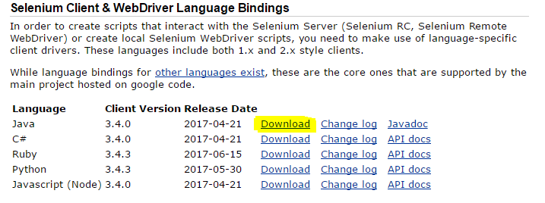

**Step 2:**

Save the .zip file to you disk.

**Step 3:**

Once you have downloaded the archive you will need to **Extract** the zip file, which will create the unzipped Selenium Java folder.

**Step 4:**

Once the extraction process is complete, **Open** the Selenium folder.

**Step 5:**

There will be ‘**libs**‘ folder, 1 jar file, 1 License file, and 1 Notice file in unzipped folder as shown in bellow figure. We will use all these files for configuring WebDriver in Eclipse.

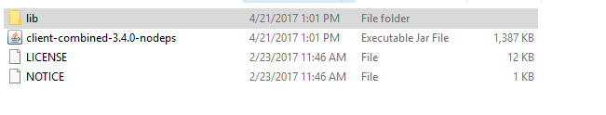

## **Configure Eclipse with Selenium WebDriver**

To configure Eclipse with Selenium WebDriver, we need to perform the following activities:

* Launch the Eclipse IDE & Create a Workspace
* Create a new Project
* Create a new Package
* Create a new Class
* Add External libraries to the project

As we know how to write java program in Eclipse, we are not going to cover Launching Eclipse, Creating new project, package and class.

Once create a project, package and class have created we need to add Selenium WebDriver’s Jar files in to Java build path.

**Add External Jars to Java build path**

**Step 1:**

Right click on Project then select Properties. Click on Java Build Path from left panel.

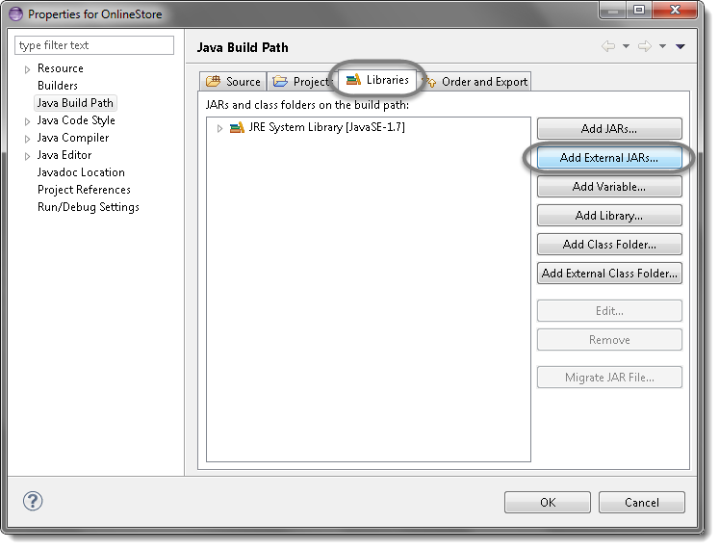

**Step 2:**

Add Selenium Java jar.

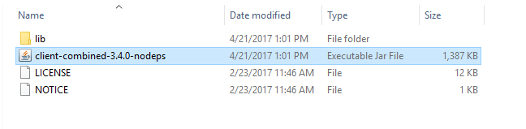

**Step 3:**

Add all the jars from the ***libs*** folder as well.

## 

**Step 4:**

Click OK.

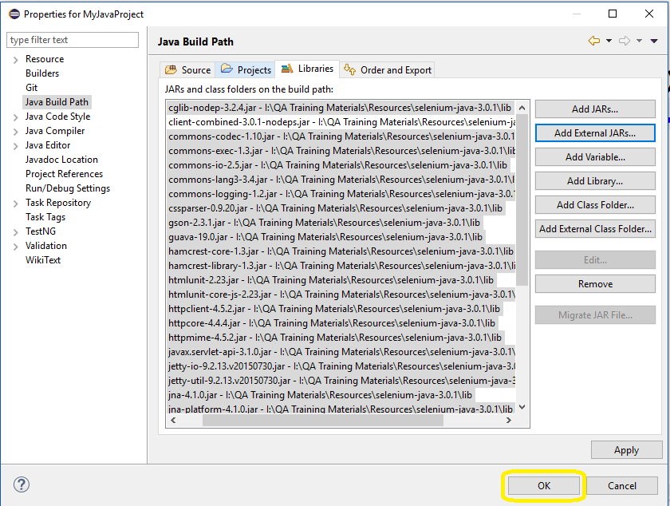

## That’s all about*configuration of WebDriver with eclipse*. Now we are ready to write our test script in eclipse and run it in WebDriver.